**PFP Robot User Manual**

**The Robot**

The robot is a six-wheel drop-center design using pneumatic tires allowing it to traverse a variety of different terrain. The drivetrain is set up in a tank configuration where each side can be operated independently.

Turning the robot on and off

To turn the robot on locate the main breaker (shown in the figure below) and rotate the black lever on the side in so that it is flush with the body of the device. It will snap into place and the lights on the various electrical parts should illuminate.

To turn off the robot, again locate the main breaker and push the red button on the top. The lever that you pressed in early should pop out and all the lights on the electrical parts should go out.

*Figure 1 - Main Breaker*

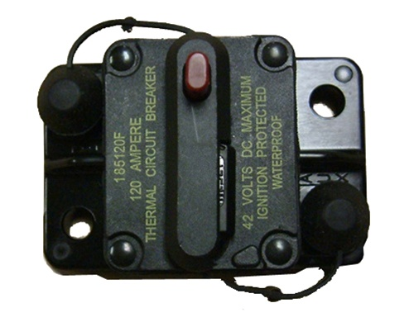

Rotate this lever until it snaps in place to turn on the robot

Press this button in to turn off

**The Controller**

The robot is operated with a standard, wireless Xbox 360 controller. A combination of the on-board LEDs and vibration motors is used to indicate the current status of the robot to the driver.

Connecting to the robot

Once the robot is powered on hold down the **HOME** button on the controller (the round one in the center with the green X on it) until the LEDs light up. It will then begin searching for the robot. When it finds it the LEDs should change from all flashing to some solid pattern. As a safety precaution the robot goes into a disabled mode and is unable to move when it is first powered on and anytime the controller becomes disconnected.

Enabling & disabling the robot

Once both the controller and robot are powered on and a connection has been established, enabling the robot is a simple matter of clicking the **START** button (just to the right of the home button). The controller will vibrate to indicate that the action was completed successfully. Similarly, to disable the robot click the **START** button again, if the action was successful the controller will vibrate.

Driving the robot

Before attempting to drive the robot it is important to know if it is in full or half speed mode. To do this look at the LEDs on the controller after enabling the robot. If the upper left LED is lit (LED 1) then the robot is in half speed mode. If the upper right LED is lit (LED 2) it is in full speed mode.

As mentioned earlier, the robot is configured with a tank style drivetrain. This means that the left and right sides are controlled independently to direct the robot to move in different directions. The left and right joysticks control their respective sides of the drivetrain.

Changing speed modes (if equipped)

There are two versions of software that can be run on the PFP robot. One supports two different speed modes. One limits maximum motor output to 50% while the other allows full speed operation.

Determining if the robot software supports multiple speed modes

To determine which version is currently running on the robot look at which LED is lit when you enable the robot. If the left top LED (labeled 1) is lit then you are using the dual-mode software, if the top right LED is lit you are running the single-speed version and the remainder of this section can be ignored.

If the software currently running on the robot supports multiple speeds they can be toggled using the **BACK** button (to the left of the home button) on the controller. When the speed mode is toggled you will notice that the illuminated LED will change between 1 and 2 depending on which mode is currently active.

**Troubleshooting**

The controller never pairs to the robot

If the controller is not pairing to the robot first reboot the robot by toggling the main breaker as described in the section titled *The Robot*. Next, confirm that the batteries in the controller are not dead, when you hold down the **HOME** button you should see the various LEDs on the controller light up, if they do not, replace the controller batteries. If the issue is still not resolved, check that the green LED on the grey receiver attached to the robot is blinking, it is possible that it became unplugged, if so reattach the USB cable to the Arduino.

The robot will not turn on

Be sure that the battery is connected and has sufficient charge to power the robot. The easiest way to do this is to take the battery out of the robot and replace it with the second one which is on the charger (the lights on the charger indicate the status of any battery which is plugged in).

The robot will not enable

If the robot will not enable it is possible that the controller and/or receiver failed to properly sync. Try rebooting both the robot (by toggling the breaker) and controller (by removing the batteries and putting them back in). If the issue persists, follow the steps above in the section *The controller never pairs to the robot*. If all else fails, connect the Arduino to a PC and use a serial monitor to view diagnostic statements to help narrow down where the issue is. The serial baud rate is 115200.

I am pressing the back button but the speed mode is not changing

The most likely reason for this is that the software running on the robot is not set up for multiple speed modes. To test this follow the directions in the section above labeled *Determining if the robot software supports multiple speed modes*. If you have confirmed that the robot is running the dual speed software be sure that it is actually enabled by lightly bumping one of the joysticks and verifying that the robot moved. Once you are sure the robot is enabled try pressing the button for a full second to be sure that it is recognized.